Project Design Phase-II
Technology Stack (Architecture & Stack)
Date | 01 October 2026
Team ID | SWTID-2026-2051
Project Name | Script-Controlled ACL – Restrict Record Access Based on Field Value (ServiceNow)
Maximum Marks | 4 Marks
Technical Architecture:
A user (EEE User or Admin) works in a web browser on the local machine. All processing and storage happen on the ServiceNow cloud instance, where ACLs decide access to the Institution Details table.
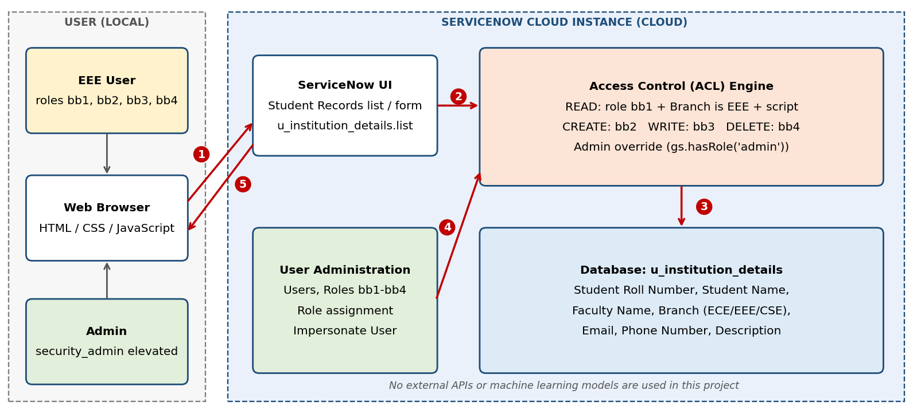
Flow: 1) user opens the records list from the browser; 2) UI request is checked by the ACL engine; 3) permitted records are read from or written to the u_institution_details table; 4) roles assigned in User Administration are used in the check; 5) the filtered result (only EEE records for bb1) is returned to the browser.
Table-1 : Components & Technologies:
S.No | Component | Description | Technology
1 | User Interface | Users open the Institution Details (Student Records) list and forms in a web browser (u_institution_details.list); the New button, inline edit and Delete action appear only if the user's roles allow it. | ServiceNow Next Experience UI / Service Portal (HTML, CSS, JavaScript)
2 | Application Logic-1 | READ ACL (Advanced): requires role bb1, data condition Branch is EEE, and an ACL script using gs.hasRole() that returns true for bb1 (and for admin in the lab's first script) and false for everyone else. | JavaScript (server-side ACL script, ECMAScript 2021 mode)
3 | Application Logic-2 | CREATE, WRITE and DELETE ACLs on u_institution_details, each requiring a custom role: bb2 (create), bb3 (write), bb4 (delete); no data condition. | ServiceNow Access Control (ACL), role-based
4 | Application Logic-3 | User and role management: EEE User created and assigned roles bb1–bb4; security_admin elevated to create ACLs; access tested by impersonating the EEE user and admin. | ServiceNow User Administration, Roles, Impersonate User
5 | Database | Custom table u_institution_details with Student Roll Number (auto number), Student Name and Faculty Name (reference to User), Branch (choice: ECE, EEE, CSE), Email, Phone Number, Description. | ServiceNow platform relational database (managed by the platform)
6 | Cloud Database | Table data is stored in the database of the cloud-hosted ServiceNow instance; no separate database service is configured. | ServiceNow instance database
7 | File Storage | Not required; the project stores only record data and no file attachments. | Not applicable (ServiceNow attachments available if needed)
8 | External API-1 | Not used; no third-party services are called. | Not applicable
9 | External API-2 | Not used. | Not applicable
10 | Machine Learning Model | Not applicable; access decisions are rule-based (roles, data condition, script). | Not applicable
11 | Infrastructure (Server / Cloud) | Application is configured and run on a ServiceNow cloud instance (Global scope, update set “ACL Project”) and accessed through a browser. | Cloud: ServiceNow instance. Local Server Configuration: none (client needs only a web browser). Cloud Server Configuration: ServiceNow-hosted instance.
Table-2: Application Characteristics:
S.No | Characteristics | Description | Technology
1 | Open-Source Frameworks | The solution uses ServiceNow platform features and standard JavaScript; no additional open-source frameworks are added. | JavaScript (ECMAScript 2021 mode in ACL script)
2 | Security Implementations | Record-level READ, CREATE, WRITE and DELETE ACLs; role-based access (bb1–bb4); data condition on Branch; script-controlled decision; admin override; security_admin elevation required to edit ACLs; verification by impersonation. | ServiceNow ACLs, Role-Based Access Control (IAM controls)
3 | Scalable Architecture | Multi-tier platform (browser, application, database). The same ACL pattern can be reused for other tables or branches by adding roles and conditions, without changing the application code. | ServiceNow multi-tier platform architecture
4 | Availability | The application runs on a cloud-hosted ServiceNow instance, so hosting, availability and infrastructure are managed by the platform. | ServiceNow cloud hosting
5 | Performance | ACL rules are evaluated on the server for each access; role and data conditions are kept simple and the script is short (a few lines) so evaluation stays fast. | Server-side ACL evaluation; condition-based filtering

